**[02-OperatorsinPython](https://www.rajalakshmicolleges.net/moodle/course/view.php?id=84&section-2)**

**Ex. No. : 2.1 Date: 20/3/24**

**Register No.: 231801171 Name:Stergio Eugin**

## [WidgetsandGizmos](https://www.rajalakshmicolleges.net/moodle/mod/quiz/view.php?id=5695)

Anonlineretailersellstwoproducts:widgetsandgizmos.Eachwidgetweighs75grams.Eachgizmoweighs112grams.Writeaprogramthatreadsthenumber ofwidgets and the number of gizmos from the user. Then your program should compute and display the total weight of the parts.

SampleInput 10

20

Sample Output

Thetotalweightofallthesewidgetsandgizmosis2990grams.

**For example:**

|  |  |
| --- | --- |
| **Input** | **Result** |
| 10  20 | Thetotalweightofallthesewidgetsandgizmosis2990grams. |

# Program:

a=int(input()) b=int(input())

print("Thetotalweightofallthesewidgetsandgizmosis",((a*75)+(b*112)),"grams.")

# Output:

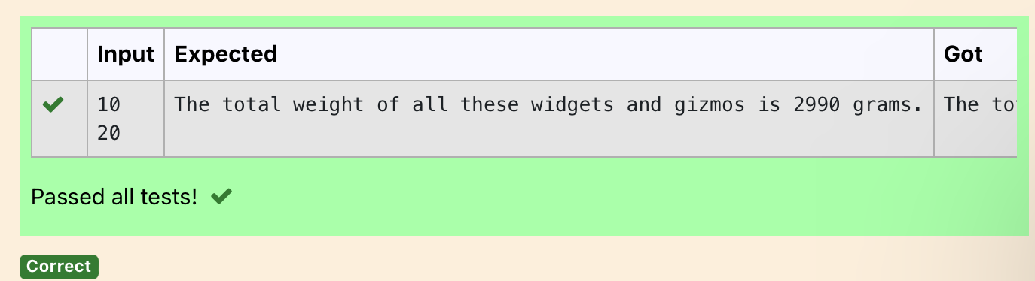

**Ex. No. : 2.2 Date: 20/3/24**

**RegisterNo.: 231801171 Name: Stergio Eugin**

## [DollSings](https://www.rajalakshmicolleges.net/moodle/mod/quiz/view.php?id=5696)

InLondon,everyyearduring Dasaratherewillbeaverygrand dollshow.Peopletry to invent new dolls of different varieties. The best-sold doll's creator will be awarded with a cash prize. So people broke their heads to create dolls innovatively. Knowing this competition, Mr.Lokpaul tried to create a doll that sings only when an even number is pressed and the number should not be zero and greater than 100.

IFLokpaulwinsprinttrue,otherwisefalse. Sample Input

10

SampleOutput True Explanation:

Since10isaneven numberandanumberbetween0and100,Trueisprinted

# Program:

a=int(input())

if(a>0anda<100anda%2==0): print("True")

else:

print("False")

# Output:

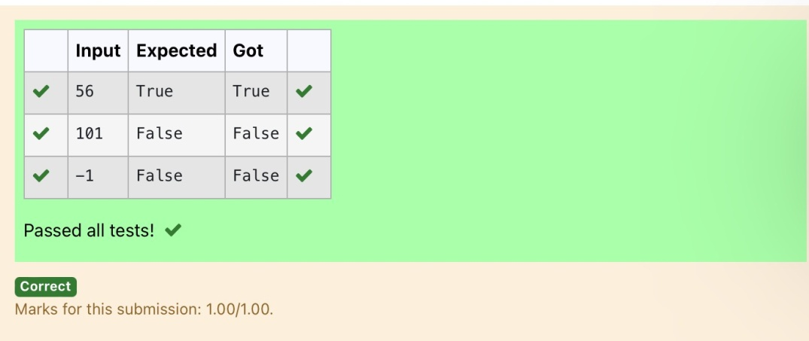

**Ex. No. : 2.3 Date: 20/3/24**

**Register No.: 231801171 Name: Stergio Eugin**

## [BirthdayParty](https://www.rajalakshmicolleges.net/moodle/mod/quiz/view.php?id=5697)

Mr.X'sbirthday isinnextmonth.Thistimehe isplanning to invite N of hisfriends. Hewantstodistributesomechocolatestoallofhisfriendsaftertheparty.Hewentto a shop to buy a packet of chocolates. At the chocolate shop, 4 packets are there with different numbers of chocolates. He wants to buy such a packet which contains a numberofchocolates, whichcanbedistributed equallyamongallofhisfriends.Help Mr. X to buy such a packet.

Input Given:

N-Noof friends

P1,P2,P3ANDP4-Noofchocolates OUTPUT:

"True"ifhecanbuythatpacketand"False"ifhecan'tbuythatpacket. SAMPLE INPUT AND OUTPUT:

5

25

12

10

9

OUTPUT

TrueFalseTrue False

# Program:

a=int(input()) b=int(input()) c=int(input()) d=int(input()) e=int(input())

print(b%a==0,c%a==0,d%a==0,e%a==0)

# Output:

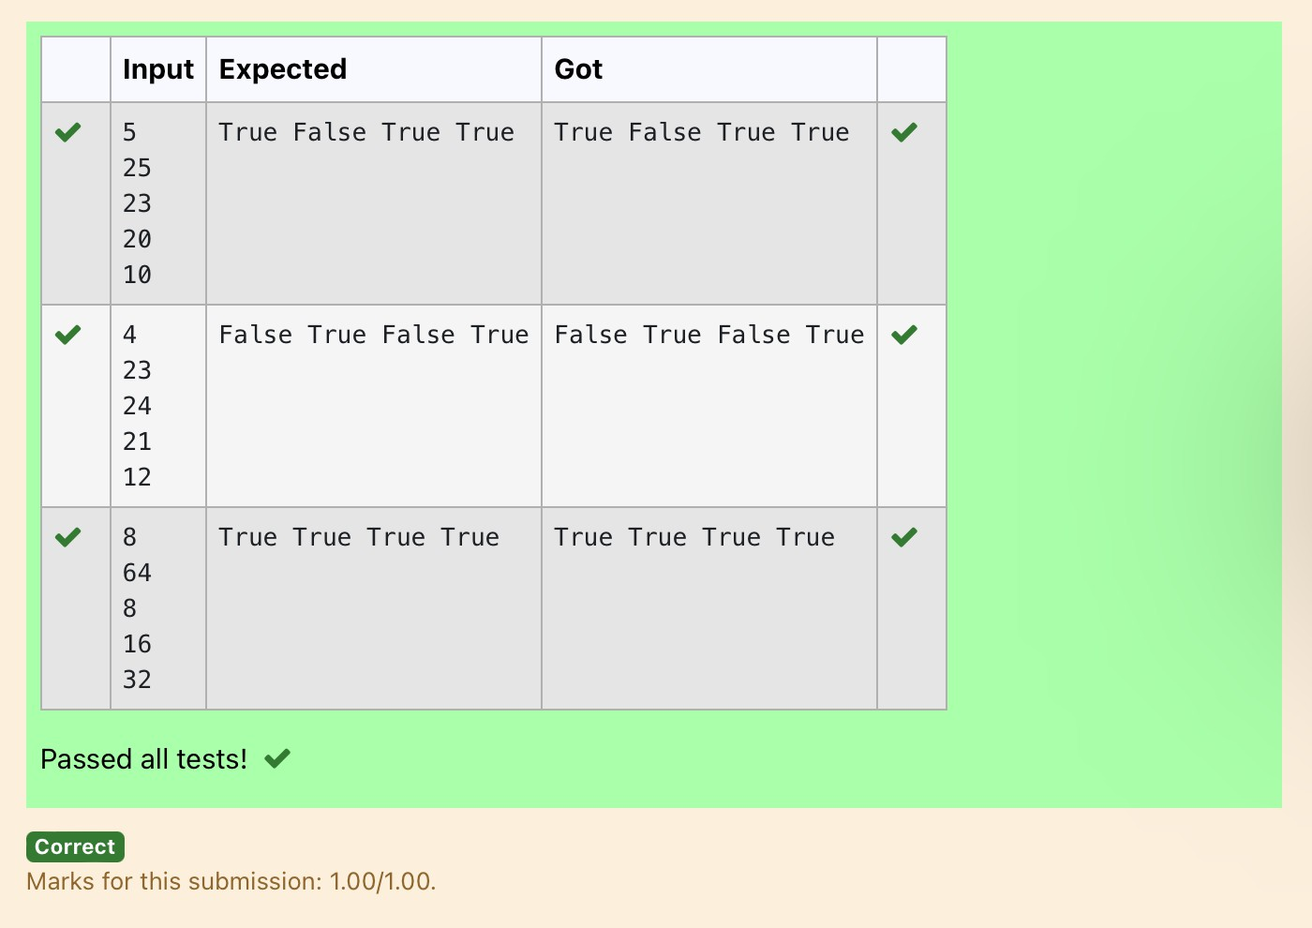

**Ex. No. : 2.4 Date: 20/3/24**

**Register No.: 231801171 Name: Stergio Eugin**

## [HammingWeight](https://www.rajalakshmicolleges.net/moodle/mod/quiz/view.php?id=5698)

Writeapythonprogramthattakesa integer between0and 15asinputand displays the number of '1' s in its binary form.(Hint:use python bitwise operator.

SampleInput 3

Sample Output:

2

Explanation:

Thebinaryrepresentationof3is011,hencethereare2ones init. sotheoutputis 2.

# Program:

a=int(input()) n=bin(a) n=n.replace("0b","") s=str(n)

c=list(s) d=0

foriinrange(len(c)): if(int(c[i])==1):

d+=1

print(d)

# Output:

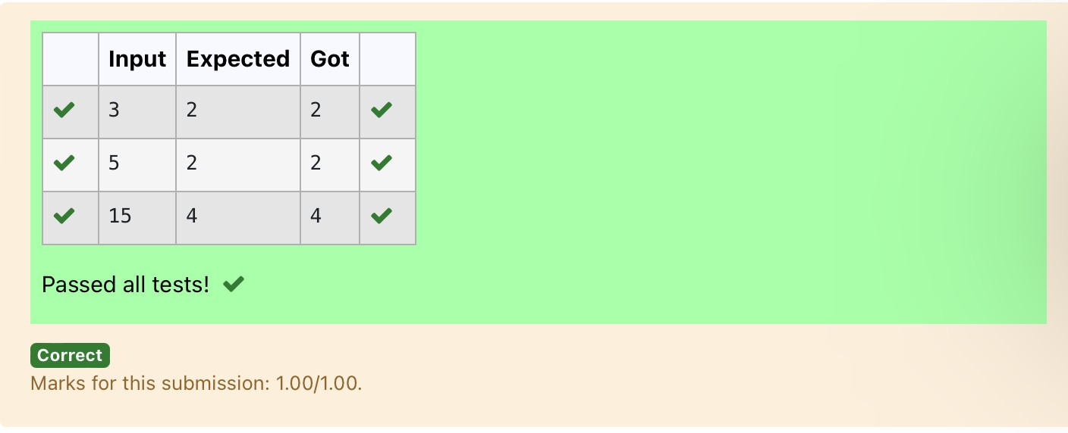

**Ex. No. : 2.5 Date: 20/3/24**

**Register No.: 231801171 Name: Stergio Eugin**

## [CompoundInterest](https://www.rajalakshmicolleges.net/moodle/mod/quiz/view.php?id=5699)

Pretend that you have just opened a new savings account that earns 4 percent interestper year. The interest that you earn is paid at the end of the year, and is added to thebalance of the savings account. Write a program that begins by reading the amount ofmoney deposited into the account from the user. Then your program shouldcompute anddisplaytheamountinthesavingsaccountafter1,2,and3years. Display each amount so that it is rounded to 2 decimal places.

Sample Input:

10000

Sample Output:

BalanceasofendofYear1:$10400.00. BalanceasofendofYear2:$10816.00. Balance as of end of Year 3: $11248.64

# Program:

a=int(input()) b=(a*0.04)+a c=b+(b*0.04) d=c+(c*0.04)

print("BalanceasofendofYear1:${:.2f}.".format(b)) print("Balanceas of end of Year2:${:.2f}.".format(c)) print("BalanceasofendofYear3:${:.2f}.".format(d))

# Output:

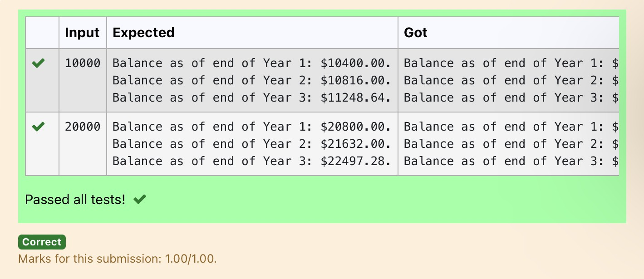

**Ex. No. : 2.6 Date: 20/3/24**

**Register No.: 231801171 Name: Stergio Eugin**

## Eligibletodonateblood

A team from the Rotract club had planned to conduct a rally to create awareness amongtheCoimbatorepeopletodonateblood.They conducted the rally successfully. Many of the Coimbatore people realized it and came forward to donate their blood to nearby blood banks. The eligibility criteria for donating blood are people should be aboveorequalto18and his/herweight should beabove40.Therewasahugecrowd and staff in the blood bankfound it difficult to managethe crowd. So they decided to keep a system and ask the people to enter their age and weight in the system. If a person is eligible he/she will be allowed inside.

Writeaprogramandfeedittothesystemtofindwhetheraperson iseligibleor not.

InputFormat:

Inputconsistsoftwointegersthatcorrespondtotheageandweightofaperson respectively.

OutputFormat:

Display True(IF ELIGIBLE) DisplayFalse(ifnoteligible) Sample Input

19

45

SampleOutput True

# Program:

a=int(input()) b=int(input()) if(a>=18andb>40):

print("True") else:

print("False")

# Output:

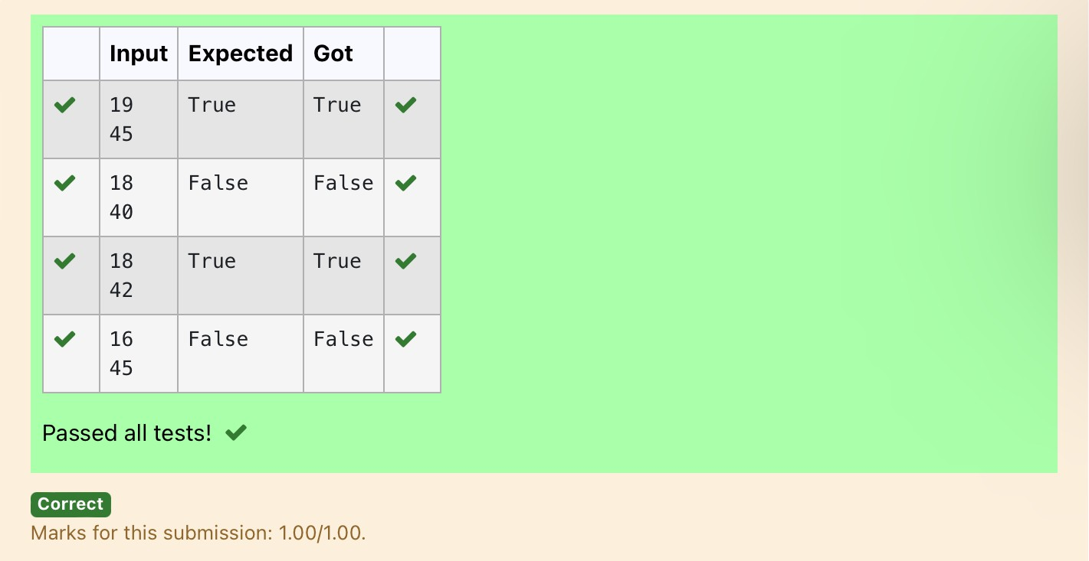

**Ex. No. : 2.7 Date: 20/3/24**

**Register No.: 231801171 Name: Stergio Eugin**

## Cor D

Mr.Ram has been given a problem kindly help him to solve it. The input of the program is either 0 or 1. IF 0 is the input he should display "C" if 1 is the input it should display "D".There is a constraint that Mr. Ram should use either logical operators or arithmetic operators to solve the problem, not anything else.

Hint:

UseASCII valuesofCand D.

### InputFormat:

Anintegerx,0<=x<=1..

### OutputFormat:

outputasinglecharacter"C"or"D"dependingonthevalueofx.

**Input1:**

0

**Output1:**

C

**Input2:**

1

**Output1:**

D

Program: a=int(input()) if(a==0):

print("C") else:

print("D")

# Output:

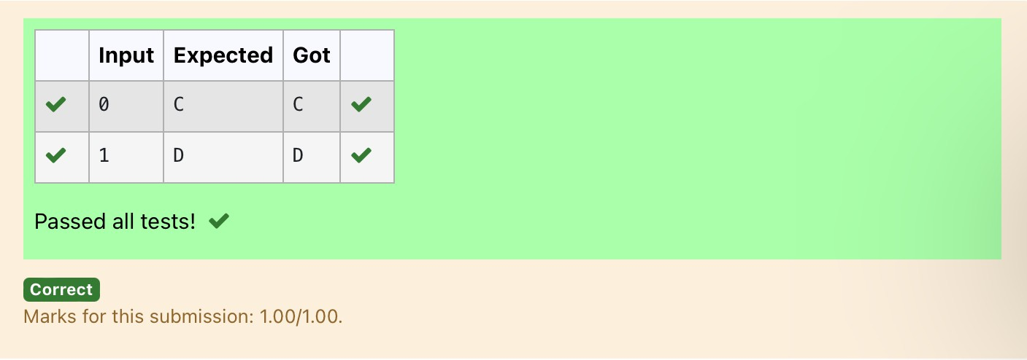

**Ex. No. : 2.8 Date: 27/3/24**

**Register No.: 231801171 Name: Stergio Eugin**

## Troy Battle

In the 1800s, the battle of Troy was led by Hercules. He was a superstitious person. He believed that his crew can win the battle only if the total count of the weapons in hand is in multiple of 3 and the soldiers are in an even number of count. Given the total numberof weaponsandthe soldier'scount,Find whetherthe battle canbe won or not according to Hercules's belief. If the battle can be won print True otherwise print False.

### Inputformat:

Line1hasthetotalnumberofweapons Line2hasthetotalnumberofSoldiers. **OutputFormat:**

IfthebattlecanbewonprintTrueotherwiseprint False.

Sample Input:

32

43

SampleOutput:' False

Program: a=int(input()) b=int(input())

if(a%3==0andb%2==0): print("True")

else:

print("False")

# Output:

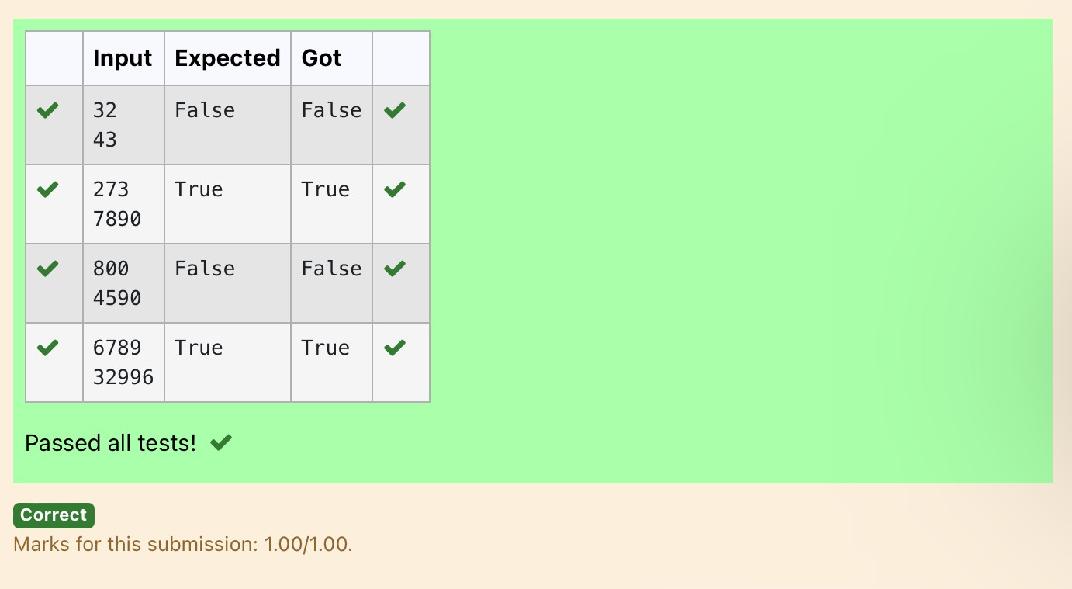

**Ex. No. : 2.9 Date: 27/3/24**

**Register No.: 231801171 Name: Stergio Eugin**

## [Taxand Tip](https://www.rajalakshmicolleges.net/moodle/mod/quiz/view.php?id=6030)

The program that you create for this exercise will begin byreading the costof a mealorderedata restaurantfromthe user. Thenyour programwill computethetax and tip for the meal.Use your local tax rate (5 percent) when computing the amount oftaxowing.Computethetipas18percentofthemealamount(withoutthetax).The output from your program should include the tax amount, the tip amount, and the grandtotalforthemealincludingboththetaxandthetip.Formattheoutputsothat all of the values are displayed using two decimal places.

SampleInput 100

Sample Output

Thetaxis5.00andthetipis18.00,makingthetotal123.00

# Program:

a=int(input())

print("Thetaxis{:.2f}andthetipis{:.2f},makingthetotal

{:.2f}".format((a*0.05),(a*0.18),(a+((a*0.05)+(a*0.18)))))

# Output:

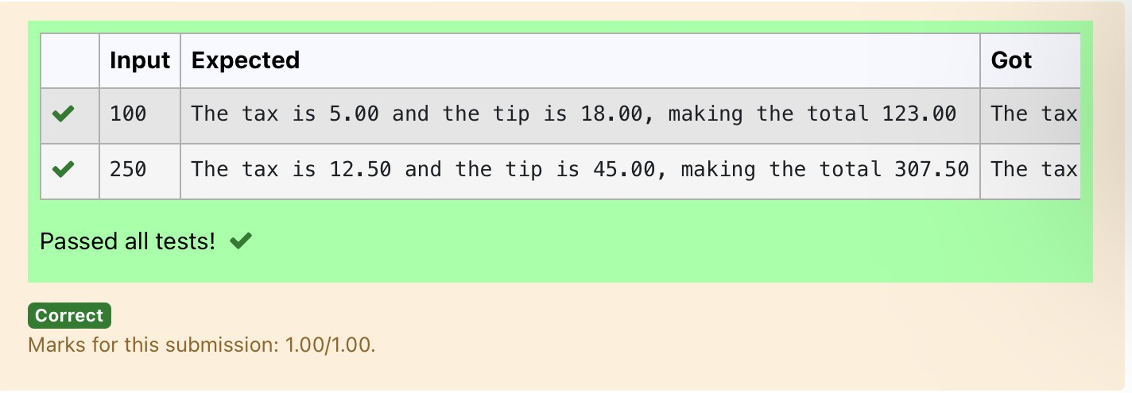

**Ex. No. : 2.10 Date: 27/3/24**

**Register No.: 231801171 Name: Stergio Eugin**

## [Returnlastdigitofthegivennumber](https://www.rajalakshmicolleges.net/moodle/mod/quiz/view.php?id=6031)

Write a program that returns the last digit of the given number. Last digit is being referredtotheleastsignificantdigiti.e.thedigitintheones(units)placeinthegiven number.

Thelastdigitshouldbereturnedasapositivenumber. For example,

if the given number is 197, the last digit is 7 ifthegivennumberis-197,thelastdigitis7 **For example:**

|  |  |
| --- | --- |
| **Input** | **Result** |
| 123 | 3 |

Program: a=int(input()) print(abs(a)%10)

Output:

